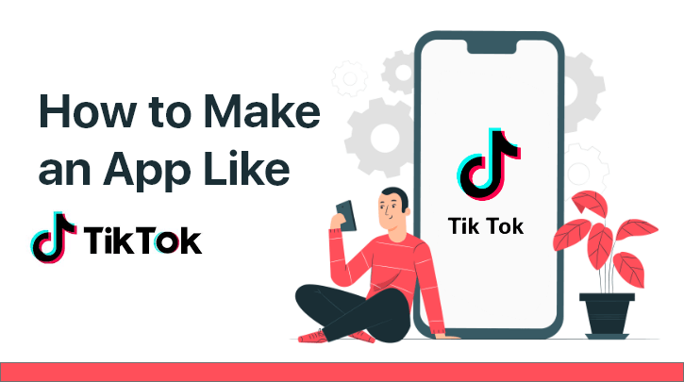
Step by step instructions to Develop an App Like TikTok-Features, Planning and Estimate Cost
In the event that you are one of the web-based media devotees, you don't have to comprehend what's the primary purpose for the achievement of video-sharing and substance sharing applications like TikTok. With the new buzz, TikTok has been making, and the immense chances for individuals who love to make recordings and DIY content, it has become the most mainstream online media application somewhat recently. Each cell phone and individuals everywhere on the world have been utilizing this online media stage to either share their video or to appreciate the great substance, particularly during available energy.
Be that as it may, there are additionally other online media stages accessible, however assuming one needs to get organizations quicker, creating application like TikTok would be an incredible alternative.
On the off chance that you are too hoping to even consider creating TikTok Clone application yet don't have a clue where to begin, here is the reason and how to make an application like TikTok.

Market Analysis and Statics of TikTok App
Inside two years of its reality, TikTok has offered rivalry to the greatest video sharing applications like Twitter, Snapchat, and YouTube, and today, it has in excess of 500 million dynamic clients from more than 155 nations in 75 dialects.
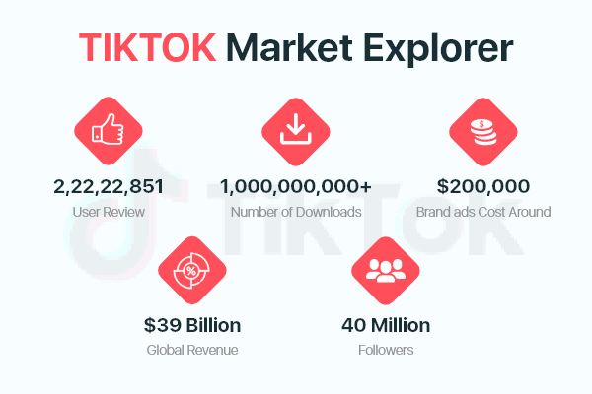
In 2019, TikTok turned into the most downloaded application in a quarter which is 315 Million, and here are some more insights, which will take your breath away.
- The brand promotions cost around $200,000 on TikTok
- TikTok's month to month income is around $4 million every month which is to be expanded around 16% until 2021-22
- Worldwide TikTok income came to $39 Billion and the greatest market of TikTok is India and China

Isn't it stunning?
What Makes TikTok So Popular?.
A video-sharing online media application where clients sing, dance, act, make DIYs and do all that connects with the crowd. TikTok was recently known as Musical.ly, created by a Chinese organization, and now, it has become a worldwide brand, which motivated more organizations to think of such applications and bring in cash..
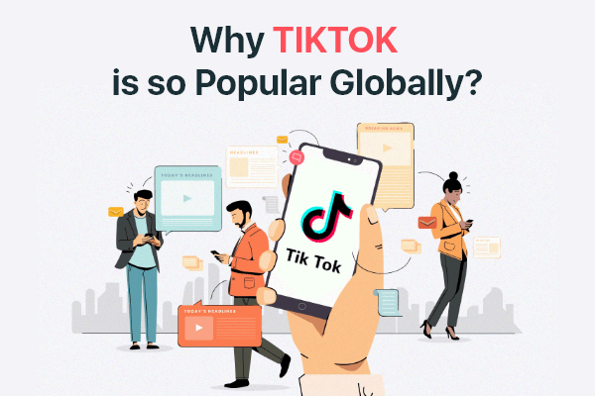
Indeed, there is no single response to why TikTok is so well known, and what makes it so engaging, yet most of individuals are dependent on its channels, audio cues, and notoriety openness. Youngsters who need to become "online media influencers" are getting a great many likes by transferring their recordings, which might be the purpose for TikTok's inconceivable income. As per its examination, youths between 14 to 25, are the essential clients of TikTok.
How to Start Developing an App Like TikTok?
Since you comprehend what makes TikTok so famous among young people, and the amount it has procured over the most recent two years, you definitely realize that it is so critical to cause the most out of your speculation so you to improve results from your potential video-sharing TikTok like App Development, Here are the principle variables to create application like TikTok
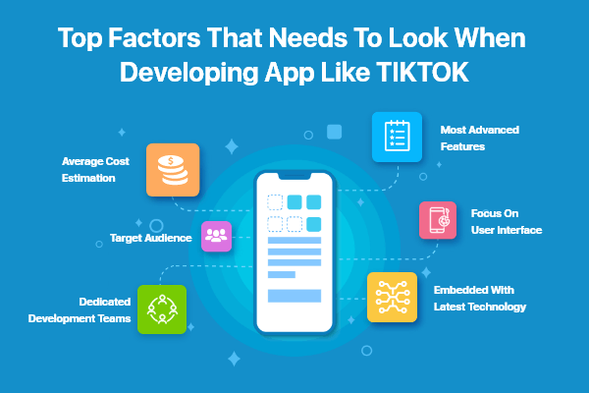
- Find Your Target Audiencek
To make your application fruitful, you should investigate your intended interest group and market openings for comparative applications like TikTok. Comprehend the necessities of your intended interest group, and contrast it with the current applications with make something better that will draw in more clients. From discovering areas, the normal age to stamp gadgets individuals for the most part use, you need to note down everything, prior to proceeding onward to TikTok like App Development

- Average Cost Estimation for App
Prior to getting forward to assemble a TikTok like application, you need to see the amount it expenses to fabricate an application and make a spending that will not trouble you. On the off chance that you have seen the presentation and astonishing highlights of TikTok, you realize that it is so critical to put resources into the correct stage, right advancement group, incorporations, and advancements, and so forth Keeping every one of the elements and the plan intricacy, a few hours, and district as a primary concern, fundamental application advancement cost is around $30,000, which can increment up to $40,000 to $70,000 on the off chance that you are making music and video-production applications for Tik Tok

- Find A-Team
Discover a group that holds insight and abilities to make an application like Tiktok/TikTok Clone , and help out them in understanding your business goal and thought so they can think of the best system. Recruit the Top Mobile App Developers Team that will assist you with learning the patterns and specialized viewpoints prior to contributing. They will propose the best stage, mixes, include you at each progression, and will make your thought into the real world. Searching for all that group can take a great deal of exploration and time however.

- Features Required for a Successful App
Before your arrangement to build up an application like Tiktok/TikTok Clone , you should know how Tiktok functions.

- Login and Profile Settings
Like some other application, TikTok empowers clients to enlist themselves with a username by joining and adding individual subtleties.

- Video Making/Editing

The main component of your TikTok-like application, where clients can record short recordings, add impacts, yield, and test with the speed prior to transferring it. They can likewise pick the foundation, music, or sound chronicle highlight to communicate their imagination.

- Channels and Camera Effects
TikTok is well known for its astonishing excellence impacts, channels, and video altering highlights. To construct an application like TikTok or TikTok Clone , you should have impacts that are not difficult to utilize and can upgrade the presence of the clients.

- Social Sharing
Aside from sharing it on the application, clients can share their recordings on other online media stages by connecting their profiles to other web-based media accounts.

- Live Streaming
Live streaming is getting very famous via web-based media, where makers visit with their adherents live, and answer their inquiries or fund-raise for any occasion.

- Two part harmony Option
Clients who have comparative options can work together and make viral recordings with hashtags and proposals.

- Responses, Likes and Comments
Like Instagram and TikTok, you can empower responses for clients so they can comprehend if their substance is being enjoyed or not.

Different highlights like TikTok which you ought to remember for your application

- Or on the other hand Code Scanner
- Area and Introduction
- Hashtags
- Examination
- Soundtracks

Prescribed Reading-How to Build a Mobile App Like Tinder?
- Design and Development
While building up a video sharing application, your plans and convenience assume an enormous part in giving consistent client experience. Make an application like TikTok with zero repetition. The UX/UI Design ought to contain usefulness, allure, and responsiveness for all clients.

Then again, improvement is a tedious interaction. Designers need to make a MVP or Minimum Viable Product as web-based media applications are perplexing and require further enhancements according to the input of its clients. Your MVP advancement involves,
- UI
- Client login and Social Media Integration
- Client Information
- Highlights (Mentioned Above)
- Assessed Time and spending plan.

When done, you can incorporate Rules and Guidelines, Privacy Terms, and In-App Purchase highlights to make the application dependable and solid.

- Technical Requirements to Develop an App Like TikTok
In spite of the fact that your improvement group deals with everything from configuration, creating to testing, and dispatching applications, you actually should know why the application advancement cost is somewhat higher than regular online media applications for Tik Tok.

    - Content Delivery and Graphics
    - Stage (iOS and Android)
    - Data set Management
    - Online Media Integration
    - Publicizing and In-App Purchase
    - Installment Gateway Integration
    - Sound and Visual Effects
    - Client Management
    - UI and UX plan
    - Testing
How Do Apps like TikTok Make Money?
Once your application is created and prepared for dispatch, you need to get familiar with the commercial center and adaptation interaction to begin acquiring application improvement cost from your application. Here are a couple of choices to adapt your application.
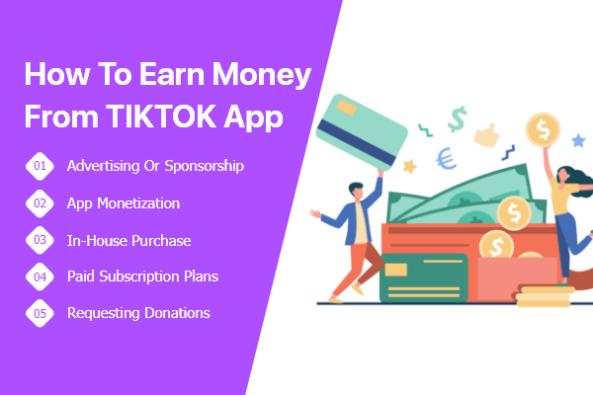

- In-App Purchase
TikTok empowers its clients to stream live by utilizing coins and buy choices. These coins can be utilized as genuine cash during live streaming. You can likewise make premium highlights that are just accessible for premium clients who pay for month to month or yearly membership charges.
- Promoting
The most widely recognized at this point successful alternative to bring in cash from versatile applications for TikTok is publicizing or sponsorship. You can contact supports who may be keen on putting their advertisements on your application and pay for item and administration advancements.
- Raising money
At first, you can discover financial backers who are keen on your thoughts, and put resources into the superior highlights of your application.

Recruit the Best Mobile App Development Team for Your Business
Online media applications for TikTok, Dub crush, and more are getting more well known in the age bunch between 14 to 35; the best objective crowd to produce income from. Nonetheless, you should have newness in your application so that individuals are attracted to it and begin preferring your plan and highlights. To make your web-based media application fruitful, you need to depend in a group that offers top notch versatile application improvement benefits at the most serious cost.
Discussing elite administrations, Maven Cluster is the conspicuous portable application improvement Company in India, making bespoke versatile applications for customers all throughout the planet. Our group is refreshed with the most recent patterns and front line advances to assist you with making TikTok Clone with cutting edge highlights to make it remain ahead in the opposition. Along these lines, stand by no more, and call our specialists to begin and use our portable application improvement administrations for TikTok like App Development.

